Flight Reservation System
Scenario we are using:
A small multi-airline booking platform that:
  - Works with several airlines (multi-airline),
  - Some of those airlines are single-airline domestic carriers,
  - Some are regional airlines with multiple hubs.
So, in one system:
  - Airline A: only domestic flights, 1 main hub → “single airline domestic routes”.
  - Airline B: regional, multiple hubs → “regional airline with multiple hubs”.
  - Our platform: sells tickets for all of them → “small multi-airline booking platform”.

1. Airline - Stores information about airlines that operate flights.
2. Airport - Stores airports where flights depart and arrive.
3. AircraftType - Defines aircraft models used for flights, including total seat capacity.
4. CabinClass - Stores cabin categories such as Economy (Y) and Business (J).
5. Flight (Route) - Represents a flight route (e.g., TAS → SKD), not tied to specific dates.
6. FlightInstance - Specific date-based flight occurrences (e.g., UZB101 on 2025-10-01).
7. FlightCabinFare - Stores fare (price) information for each flight and cabin class.
8. Passenger - Stores passenger personal information and optional frequent-flyer details.
9. Booking - Represents a reservation made by a customer (PNR, contact info, total cost).
10. BookingPassenger - Connects bookings to passengers (one booking may contain multiple passengers).
11. BookingSegment - Represents individual flight segments inside a booking.
12. Ticket - Represents issued tickets for passengers and segments, including fare and status.
13. Seat - Defines seat layout for each aircraft model (seat number + cabin class).
14. SeatAssignment - Stores which passenger sits in which seat on which flight instance.
15. Payment - Stores payments made toward bookings (method, amount, status).

1.1 Airline:
airline_id (PK)
code (e.g., “UZB”)
name
contact_phone
contact_email
country
1.2 Airport:
airport_id (PK)
code (IATA, e.g., “TAS”) – UNIQUE
name
city
country
time_zone
1.3 AircraftType:
aircraft_type_id (PK)
model (e.g., “A320-200”)
manufacturer (e.g., “Airbus”)
total_seat_capacity
1.4 CabinClass:
cabin_class_id (PK)
code (e.g., “Y”, “J”)
name (Economy, Business)
1.5 Flight (Route):
flight_id (PK)
airline_id (FK → Airline)
flight_number (e.g., “UZB123”)
departure_airport_id (FK → Airport)
arrival_airport_id (FK → Airport)
sched_departure_time (time of day)
sched_arrival_time (time of day)
aircraft_type_id (FK → AircraftType)
1.6 FlightInstance:
flight_instance_id (PK)
flight_id (FK → Flight)
flight_date (DATE)
status (scheduled, delayed, cancelled, departed, arrived)
actual_departure_datetime (nullable)
actual_arrival_datetime (nullable)
1.7 FlightCabinFare:
flight_cabin_fare_id (PK)
flight_id (FK → Flight)
cabin_class_id (FK → CabinClass)
base_fare_amount
currency_code
fare_type (refundable, non_refundable, flexible)
2.1 Passenger:
passenger_id (PK)
first_name
last_name
date_of_birth
email
phone
id_document_number (passport/ID)
id_document_type
frequent_flyer_number (nullable)
frequent_flyer_program (nullable)
2.2 Booking:
booking_id (PK)
booking_reference (PNR, UNIQUE)
creation_datetime
status (booked, ticketed, cancelled)
total_amount (expected total price)
currency_code
contact_email
contact_phone
2.3 BookingPassenger:
booking_passenger_id (PK)
booking_id (FK → Booking)
passenger_id (FK → Passenger)
passenger_role (primary, secondary, child, etc.)
2.4 BookingSegment:
booking_segment_id (PK)
booking_id (FK → Booking)
flight_instance_id (FK → FlightInstance)
cabin_class_id (FK → CabinClass)
segment_order (1, 2, 3… to keep itinerary order)
2.5 Ticket
ticket_id (PK)
ticket_number (UNIQUE, printable)
booking_id (FK → Booking)
booking_passenger_id (FK → BookingPassenger)
booking_segment_id (FK → BookingSegment)
issue_datetime
fare_amount
currency_code
status (valid, used, refunded, void)
3.1 Seat:
seat_id (PK)
aircraft_type_id (FK → AircraftType)
seat_number (e.g., “12A”)
cabin_class_id (FK → CabinClass)
3.2 SeatAssignment:
seat_assignment_id (PK)
flight_instance_id (FK → FlightInstance)
seat_id (FK → Seat)
booking_passenger_id (FK → BookingPassenger)
booking_segment_id (FK → BookingSegment)
4.1 Payment:
payment_id (PK)
booking_id (FK → Booking)
amount
currency_code
payment_method (card, cash, wallet)
payment_datetime
status (successful, failed, refunded)

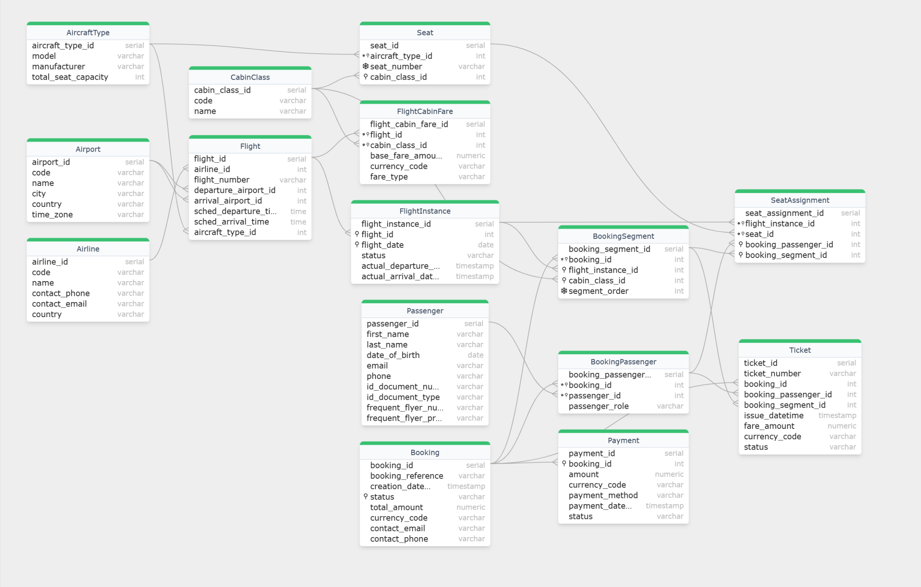

1. Airlines
airline_id | code | name | country | notes
1 | UZB | UZB Air | Uzbekistan | Domestic-focused carrier
2 | SRG | SilkRegional | Uzbekistan | Regional multi-hub airline
3 | STW | SteppeWings | UAE | International carrier

2. Airports by Country / Branch

2.1 Uzbekistan (Domestic Branch)
airport_id | code | city | country | branch / role
1 | TAS | Tashkent | Uzbekistan | Main hub / capital
2 | SKD | Samarkand | Uzbekistan | Secondary hub (Central region)
3 | BHK | Bukhara | Uzbekistan | Central/West
4 | NMA | Namangan | Uzbekistan | East / Fergana Valley
5 | FEG | Fergana | Uzbekistan | East / Fergana Valley
6 | UGC | Urgench | Uzbekistan | West / Khorezm

2.2 Kazakhstan (Regional Branch)
airport_id | code | city | country | branch / role
7 | ALA | Almaty | Kazakhstan | Regional destination
8 | NQZ | Astana | Kazakhstan | Regional destination

2.3 International Branch
airport_id | code | city | country | branch / role
9 | DXB | Dubai | UAE | International hub
10 | IST | Istanbul | Turkey | International hub

3. Aircraft Types & Cabin Classes

3.1 AircraftType
aircraft_type_id | model | manufacturer | total_seat_capacity
1 | A320-200 | Airbus | 20
2 | B737-800 | Boeing | 24
3 | E190 | Embraer | 16

3.2 CabinClass
cabin_class_id | code | name
1 | Y | Economy
2 | J | Business

4. Flights (Routes)
flight_id | airline | flight_number | route | aircraft
1 | UZB | UZB101 | TAS → SKD | A320
2 | UZB | UZB202 | TAS → BHK | A320
3 | UZB | UZB303 | TAS → ALA | B737
4 | SRG | SRG410 | SKD → BHK | E190
5 | SRG | SRG511 | SKD → NQZ | B737
6 | SRG | SRG612 | BHK → TAS | A320
7 | STW | STW701 | TAS → DXB | B737
8 | STW | STW802 | DXB → IST | B737

5. Flight Instances (Specific Dates)
flight_instance_id | flight_number | flight_date | status | route
1 | UZB101 | 2025-10-01 | departed | TAS → SKD
2 | UZB101 | 2025-10-02 | arrived | TAS → SKD
3 | UZB101 | 2025-10-03 | scheduled | TAS → SKD
4 | UZB202 | 2025-10-01 | arrived | TAS → BHK
5 | UZB202 | 2025-10-02 | cancelled | TAS → BHK
6 | UZB202 | 2025-10-03 | scheduled | TAS → BHK
7 | UZB303 | 2025-10-01 | departed | TAS → ALA
8 | UZB303 | 2025-10-02 | arrived | TAS → ALA
9 | UZB303 | 2025-10-03 | scheduled | TAS → ALA

6. Passengers
passenger_id | name | id_document_type | frequent flyer program
1 | Ali Karimov | Passport | UZB Air Plus
2 | Laylo Rasulova | Passport | —
3 | Javlon Saidov | Passport | SilkRegional Club
4 | Aziza Nurmatova | ID Card | —
5 | Timur Yuldashev | Passport | —
6 | Madina Olimova | Passport | SteppeWings Miles
7 | Sardor Abdullaev | ID Card | —
8 | Nigora Ismailova | Passport | —
9 | Bobur Ergashev | Passport | —
10 | Dilshod Aliyev | Passport | —
11 | Zuhra Mintova | ID Card | —
12 | Michael Smith | Passport | —

7. Bookings Overview
booking_id | reference | status | passengers | total_amount (USD)
1 | AB12CD | ticketed | 1 | 160
2 | EF34GH | ticketed | 2 | 320
3 | IJ56KL | booked | 1 | 230
4 | MN78OP | ticketed | 2 | 260
5 | QR90ST | ticketed | 3 | 520
6 | UV12WX | ticketed | 4 | 730
7 | YZ34AA | booked | 1 | 140
8 | BB56CC | ticketed | 2 | 900

7.1 Booking → Segments → Airports (Meaning)
- Booking 1 (Ali): FI 2 = UZB101 on 2025-10-02, TAS → SKD
- Booking 2 (Laylo + Aziza): FI 4 = UZB202 on 2025-10-01, TAS → BHK
- Booking 3 (Javlon): FI 7 = UZB303 on 2025-10-01, TAS → ALA (Business)
- Booking 4 (Aziza + Timur): FI 10 SKD → BHK, then FI 16 BHK → TAS
- Booking 5 (family): FI 6 TAS → BHK, then FI 17 BHK → TAS
- Booking 6 (group): FI 19 = STW701 on 2025-10-01, TAS → DXB
- Booking 7 (Sardor): FI 13 = SRG511 on 2025-10-01, SKD → NQZ
- Booking 8 (Michael + Zuhra): FI 20 TAS → DXB, then FI 22 DXB → IST

